WEEK 4
MACHINE LEARNING MODEL DEVELOPMENT AND EVALUATION
Titanic Passenger Survival Prediction
Virtual Data Science with Python Apprentice Intern

1. Introduction
Week 4 focuses on machine learning model development and evaluation using Python. The cleaned Titanic dataset used in Weeks 1–3 was used to develop a binary classification model for predicting passenger survival. Logistic Regression was selected because the target variable is binary and the algorithm provides a simple, interpretable baseline model.

2. Objective
The objective was to build a machine-learning pipeline that preprocesses passenger information, trains a Logistic Regression classifier, predicts survival on unseen test data, and evaluates the model using multiple performance metrics.

3. Dataset and Features
The cleaned Titanic dataset contains 784 records and 14 variables. The target variable was survived, where 0 represents did not survive and 1 represents survived.
Features selected for prediction:
- pclass
- sex
- age
- sibsp
- parch
- fare
- embarked
The variables alive and class were excluded because they duplicate survival information or duplicate the information represented by pclass. Excluding alive also prevents data leakage.

4. Data Preprocessing
A Scikit-learn preprocessing pipeline was used. Missing numerical values were replaced with the median, while missing categorical values were replaced with the most frequent category. Categorical variables were converted into numerical features using one-hot encoding.
The dataset was divided into 80% training data and 20% testing data. A fixed random state of 42 was used for reproducibility, and stratification was applied to preserve the target-class distribution.

5. Model Selection
Logistic Regression was selected as the classification algorithm. It is suitable for binary outcomes, computationally efficient, and provides a strong baseline for evaluating whether passenger characteristics can predict survival.

6. Python Implementation
from sklearn.model_selection import train_test_split
from sklearn.compose import ColumnTransformer
from sklearn.preprocessing import OneHotEncoder
from sklearn.impute import SimpleImputer
from sklearn.pipeline import Pipeline
from sklearn.linear_model import LogisticRegression
from sklearn.metrics import (
accuracy_score, precision_score, recall_score,
f1_score, confusion_matrix, roc_auc_score
)
features = [
"pclass", "sex", "age", "sibsp",
"parch", "fare", "embarked"
]
X = df[features]
y = df["survived"]
X_train, X_test, y_train, y_test = train_test_split(
X, y, test_size=0.2, random_state=42, stratify=y
)
numeric_features = ["pclass", "age", "sibsp", "parch", "fare"]
categorical_features = ["sex", "embarked"]
numeric_transformer = Pipeline([
("imputer", SimpleImputer(strategy="median"))
])
categorical_transformer = Pipeline([
("imputer", SimpleImputer(strategy="most_frequent")),
("onehot", OneHotEncoder(handle_unknown="ignore"))
])
preprocessor = ColumnTransformer([
("num", numeric_transformer, numeric_features),
("cat", categorical_transformer, categorical_features)
])
model = Pipeline([
("preprocessor", preprocessor),
("classifier", LogisticRegression(max_iter=1000))
])
model.fit(X_train, y_train)
y_pred = model.predict(X_test)
y_probability = model.predict_proba(X_test)[:, 1]

7. Model Performance
Metric | Score
Accuracy | 0.8141 (81.41%)
Precision | 0.7692 (76.92%)
Recall | 0.7812 (78.12%)
F1 Score | 0.7752 (77.52%)
ROC-AUC | 0.8866 (88.66%)
The model achieved an accuracy of 81.41%, meaning that approximately 81 out of every 100 test passengers were classified correctly. Precision was 76.92%, while recall was 78.12%. The F1 score of 77.52% represents a balance between precision and recall. The ROC-AUC score of 0.8866 indicates good ability to distinguish between survivors and non-survivors.

8. Confusion Matrix
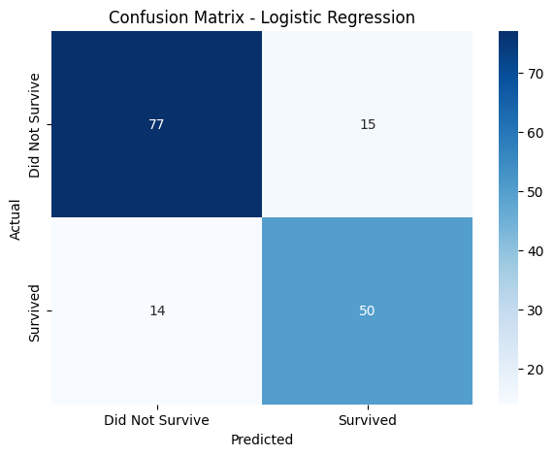
Figure 1. Confusion matrix for the Logistic Regression model.
The confusion matrix contains 77 true negatives, 50 true positives, 15 false positives, and 14 false negatives. Therefore, the model correctly classified 127 of the 156 test observations. The relatively balanced false-positive and false-negative counts indicate that the model is not strongly biased toward only one prediction outcome.

9. ROC Curve
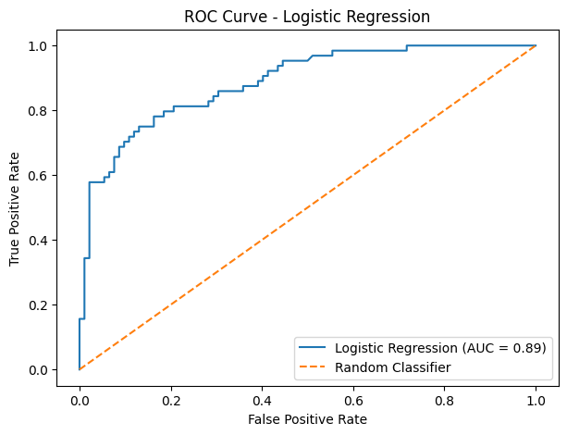
Figure 2. ROC curve for the Logistic Regression model.
The ROC curve plots the true-positive rate against the false-positive rate at different classification thresholds. The calculated ROC-AUC was 0.8866, which indicates good discriminative performance and is substantially better than the 0.50 level expected from a random classifier.

10. Error Analysis
The model made 29 errors on the test set: 15 false positives and 14 false negatives. False positives are passengers predicted to survive who did not survive, while false negatives are passengers predicted not to survive who actually survived. These errors may occur because survival depended on several interacting historical and situational factors that are not fully captured by the selected features.

11. Strengths and Limitations
Strengths:
- Uses a reproducible train/test split.
- Handles missing values within a machine-learning pipeline.
- Encodes categorical variables appropriately.
- Uses multiple evaluation metrics rather than accuracy alone.
- Achieves a strong ROC-AUC of 0.8866.
Limitations:
- Logistic Regression assumes a relatively simple relationship between predictors and the outcome.
- The model does not capture every factor that affected survival.
- The Titanic dataset is historical and may not generalize to other populations.
- Performance could change with different train/test splits or feature selections.

12. Potential Improvements
Future work could compare Logistic Regression with Decision Tree, Random Forest, or other classification algorithms. Hyperparameter tuning and cross-validation could be applied to obtain a more reliable estimate of model performance. Additional feature engineering, such as combining family-related variables or creating age groups, could also be investigated.

13. Conclusion
A Logistic Regression model was successfully developed to predict Titanic passenger survival. The model achieved 81.41% accuracy, 76.92% precision, 78.12% recall, 77.52% F1 score, and a ROC-AUC of 0.8866 on the test data. The confusion matrix and ROC curve demonstrate that the model can distinguish survivors from non-survivors reasonably well. Although the model has limitations and makes some classification errors, it provides a useful baseline for further machine-learning experiments and demonstrates a complete workflow from preprocessing to evaluation.

